# Iteration 0 Report

Team RightAfterDeadline

**Pivotal Tracker**: <https://www.pivotaltracker.com/n/projects/2437225>

**GitHub**: <https://github.com/Innoversa/Law-School-Copyright>

## Team Roles

Scrum Master: Sicong Huang

Product Owner: Sicong Huang

## Customer Meeting Information

Meeting was scheduled on February 25th from 1:30pm to 2:00pm. Meeting place is Evans Library 204E.

## Summary

Our customer is Dr. Lunney. The customer wishes to input an excel chart of book names or song names, and output an excel chart of those names with statistics like price, watch count, etc. The customer wants a program to automatically scrape data from websites such as Amazon and Youtube based on the given input excel file of books or songs. wishes us to do a data scraping on the list of books or songs he provides and gives him an empirical evaluation of these data. The input excel file will provide song/book names and attributes that the customer is looking for, such as current price, total view count, etc. We have agreed on using Python for this project because of its convenient plugin with excel format and also wide API access for data scraping operations.

## User Stories

1. Feature: find average and lowest prices for a book

As a researcher in copyrights

So that I can see price difference between books with and without copyrights

I want to see the lowest and average prices of the book from the internet

1. Feature: find view/listen count for a song

As a researcher in copyrights

So that I can see a song’s trend over the time

I want to see the view count/listen of this song from the internet

1. Feature: find the length of the song

As a researcher in copyrights

So that I can match songs with similar length

I want to see the length of the song from the internet

1. Feature: find price for both electronic copy and hard copy of a book

As a researcher in copyrights

So that I can see if electronic copy and hard copy make differences if book is copyrighted

I want to see the price of electronic copy and hard copy of a book (if applicable)

## Lo-fi User Interface

Since the function of the program is mostly about scraping data from websites, it is not interaction-intensive. Our group decides to make the program light-weight and simplify the user interface to a few user interfaces so that once everything is set up, the program can run in the background without consuming too much resource. This also makes it easier for the customer to use.

Below are sketched Lo-fi user interfaces:

User Story #1

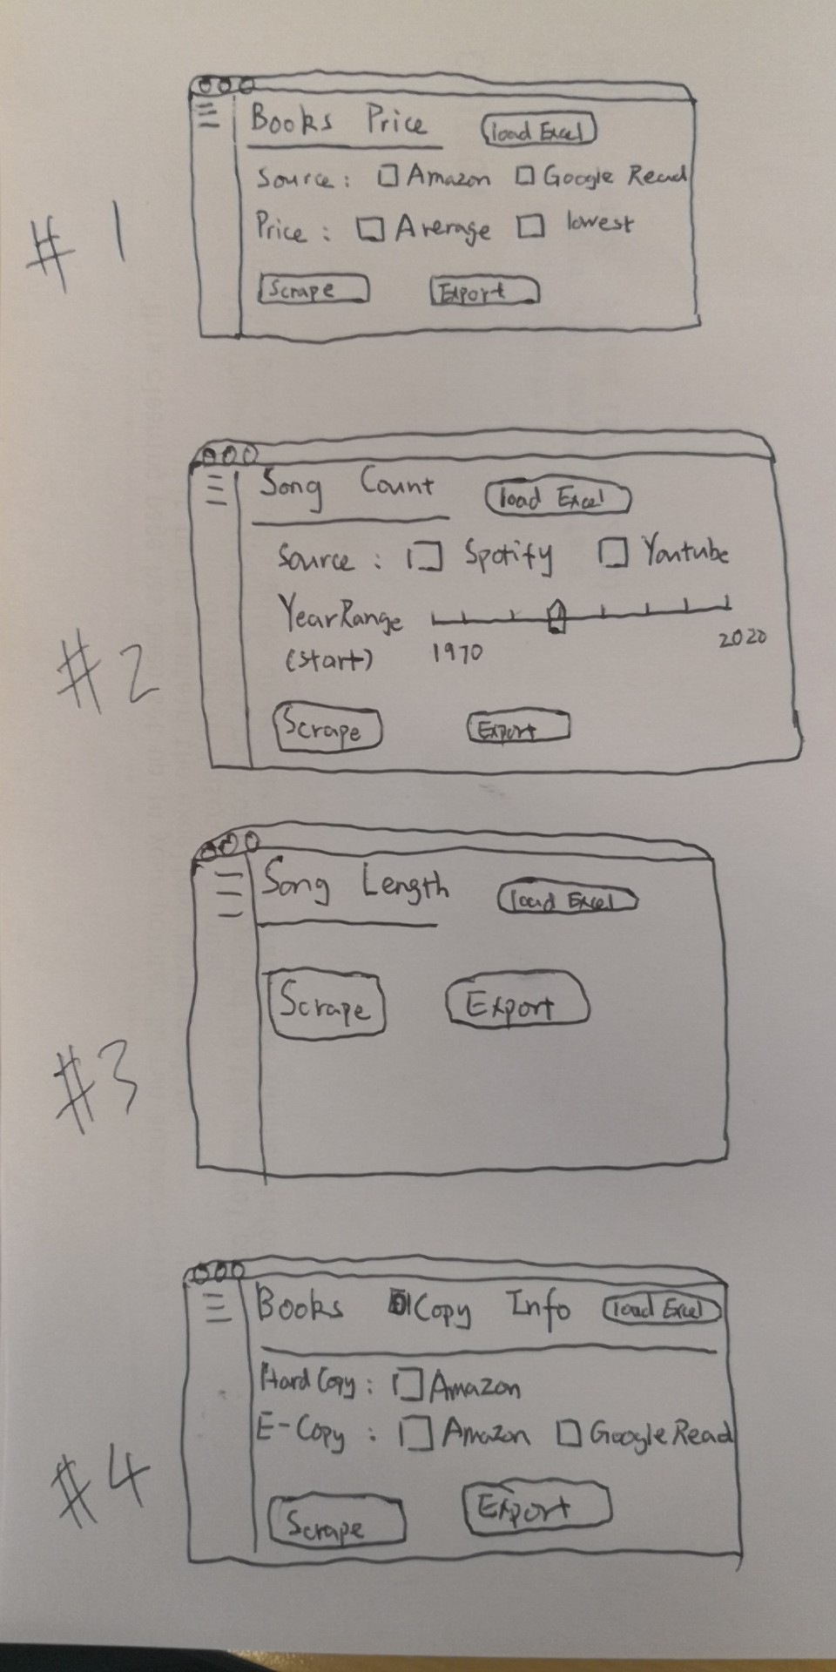

User Story #2



User Story #3



User Story #4

